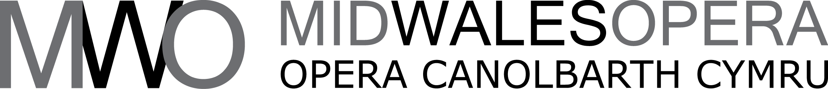

Marketing Officer Freelance contract

The fee payable for the contract period from July 2023- March 2024 will be £10,500 to £12,000 depending on experience (based around a commitment of two days per week but variable during touring periods.)

Mid Wales Opera needs a passionate and experienced marketing freelancer to join our busy team and to lead the company’s digital, press and print marketing work. You will be confident planning and executing a dynamic campaign focussing on Shakespeare Season with two tours in Autumn 2023 and Spring 2024. You will be a self-starter with a passion for the arts and a real understanding of Wales and its audiences.

Background

Mid Wales Opera was founded in 1988, growing out of community-based productions around Newtown, Powys, and has been producing professional touring opera since 1989. MWO now tours twice each year – on a SmallStages model to 13 community halls and small theatres each Autumn and with nine MainStages shows each Spring.

Brief

To work with the Executive Director and key staff to lead on all aspects of the organisation’s marketing and PR activity, which includes promoting the Autumn 2023 tour of Berlioz’s Beatrice and Benedict and Spring 2024 tour of Verdi’s Macbeth, education and outreach programmes as well as raising the profile of the company.

Online

- To generate content for and work with our web designer to update MWO’s website, liaising with the staff team and with IT professionals where necessary to ensure website security, development, accessibility & standards.

- To develop a social media campaign, working with venue staff and volunteers, to support both tours.

- Co-ordinate the organisation’s positive online profile, ensuring social media opportunities are maximised and channels are kept up to date.

- To be responsible for editing and publishing the organisation’s E-newsletters and E-invites

- To maintain and increase the organisation’s profile and brand recognition through online marketing

Marketing and Press

- To work with the Executive Director, in-house designer and with venue staff to co-ordinate the development and delivery of marketing, press and publicity materials for the organisation and ensure that campaigns are delivered on time and to agreed budgets.

- To work with key staff to co-devise and co-implement tailored marketing campaigns for specific projects as required.

- To work alongside our in-house designer to create effective print campaigns

Audience Research and Development

- To work with the staff team on research and development around both existing audiences and new audiences.

Skills and Personal Qualities

Essential

- Proven arts marketing experience
- Strong understanding of the arts in Wales and specifically rural venues
- Educated to degree level (or equivalent)
- An interest and enthusiasm for the performing arts.
- Experience of developing creative online content for a range of social media platforms – and specifically of maintaining a WordPress based website.
- Strong verbal and written communication skills
- Exceptional eye for detail and methodical approach to work
- A strong administrator with good IT and computer skills
- Organised and has good project management skills
- Ability to work unsupervised and on own initiative, with the ability to prioritise and manage own workload
- Excellent team working skills

Desirable
- Ability to communicate effectively in the medium of Welsh

How to apply

Please send a full C.V. and supporting letter of application addressing the details outlined in the Brief and Skills and Personal Qualities by email to Lydia@midwalesopera.co.uk . The post is home-based and the other key staff live and work around Mid Wales and the Borders. Own transport or ability to travel is essential.

Deadline for applications: Friday 9th June 2023
Interviews week commencing: Monday June 12th 2023

